**22.2 Filesystem Issues**

Before discussing filesystem utilities in depth, it is important to discuss the most common causes of filesystem damage. For example, one of the easiest ways to damage a filesystem is to shut down the system improperly. You should never just flip the switch on a surge suppressor or pull the plug from its power source unless the system will not respond to all other attempts to shut it down properly. In many cases, just pressing the power button once will cause many systems to shut down gracefully (this depends on the hardware and BIOS settings of the computer).

When using a graphical desktop environment, an icon may be available to begin the shutdown process. For example, within the Gnome Desktop Environment, click on the System menu and then choose Shut Down; a dialog similar to the following will be displayed:

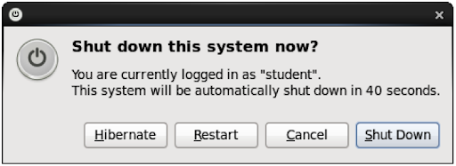

There are also a few commands available to shut down the Linux system from the command line. For example, the following init commands and user commands are available.

| **Init Command** | **Purpose** | **User Command** |
| --- | --- | --- |
| init 0 | Shut the system off | halt |
| init 6 | Restart the system | reboot |

Be aware that the init commands require root privileges, whereas the user commands do not if the user is logged in locally and there are no other users logged into the system. Also, discretion is recommended when using the init command as it is abrupt and can cause unintended consequences. In some cases, it is considered more appropriate to use the shutdown -h, shutdown -r, poweroff, or even reboot commands, many of which are links to each other.

**Note**

Linux distributions that have replaced the traditional SysVinit daemon with systemd use the systemctl command to affect the state of the system and services running. To restart a system using systemd, execute the systemctl reboot command. To shut down a system using systemd, execute using the systemctl poweroff command.